Report View

**Power BI report** is a multi-perspective view into a dataset, with visuals that represent different findings and insights from that dataset. A report can have a single visual or pages full of visuals.

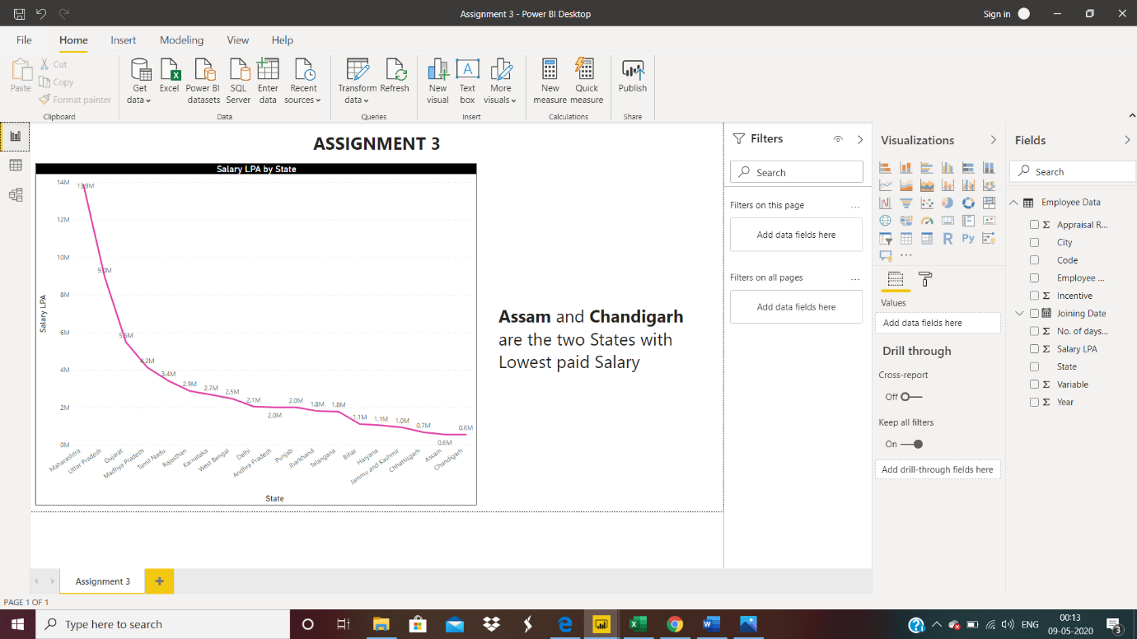

Data View

**Data view**helps you inspect, explore, and understand data in your Power BI Desktop model. With Data view, you are looking at your data after it has been loaded into the model.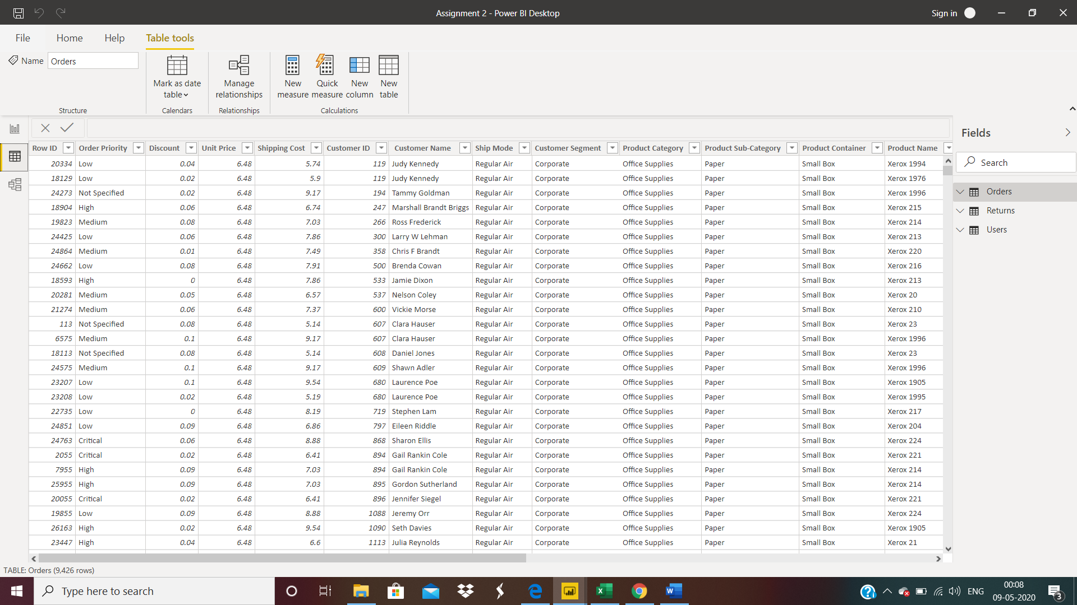

Model View

**Model view** shows all of the tables, columns, and relationships in the model. This view can be especially helpful when your model has complex relationships between many tables.

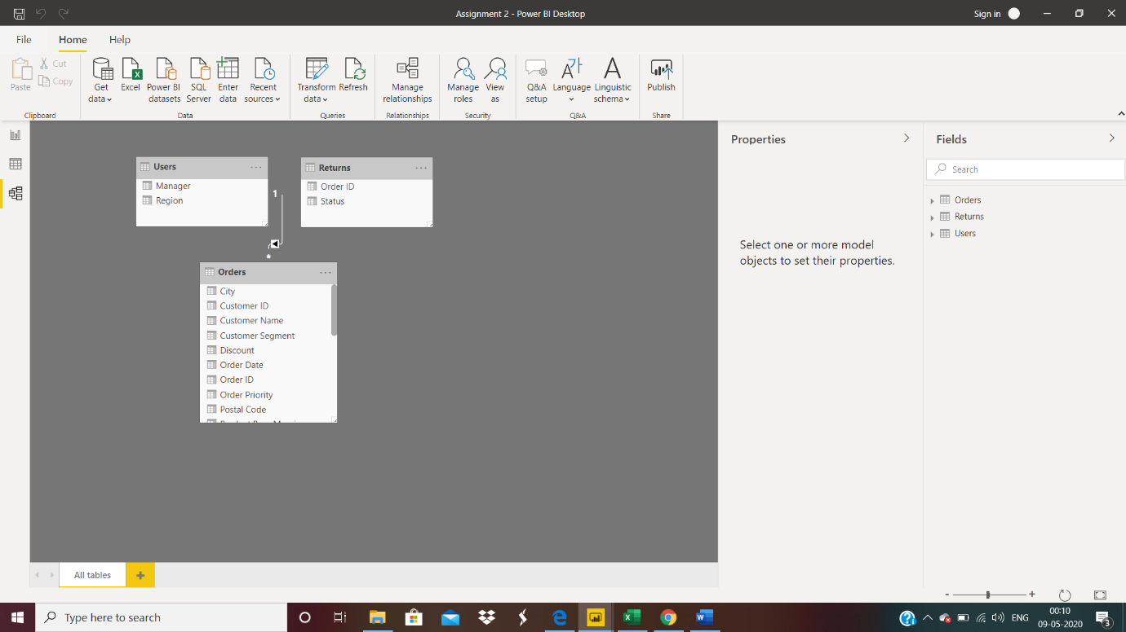

Power Query Editor

The **Query Editor** in Power BI is used to transform or edit data files before they are actually loaded into the Power BI.

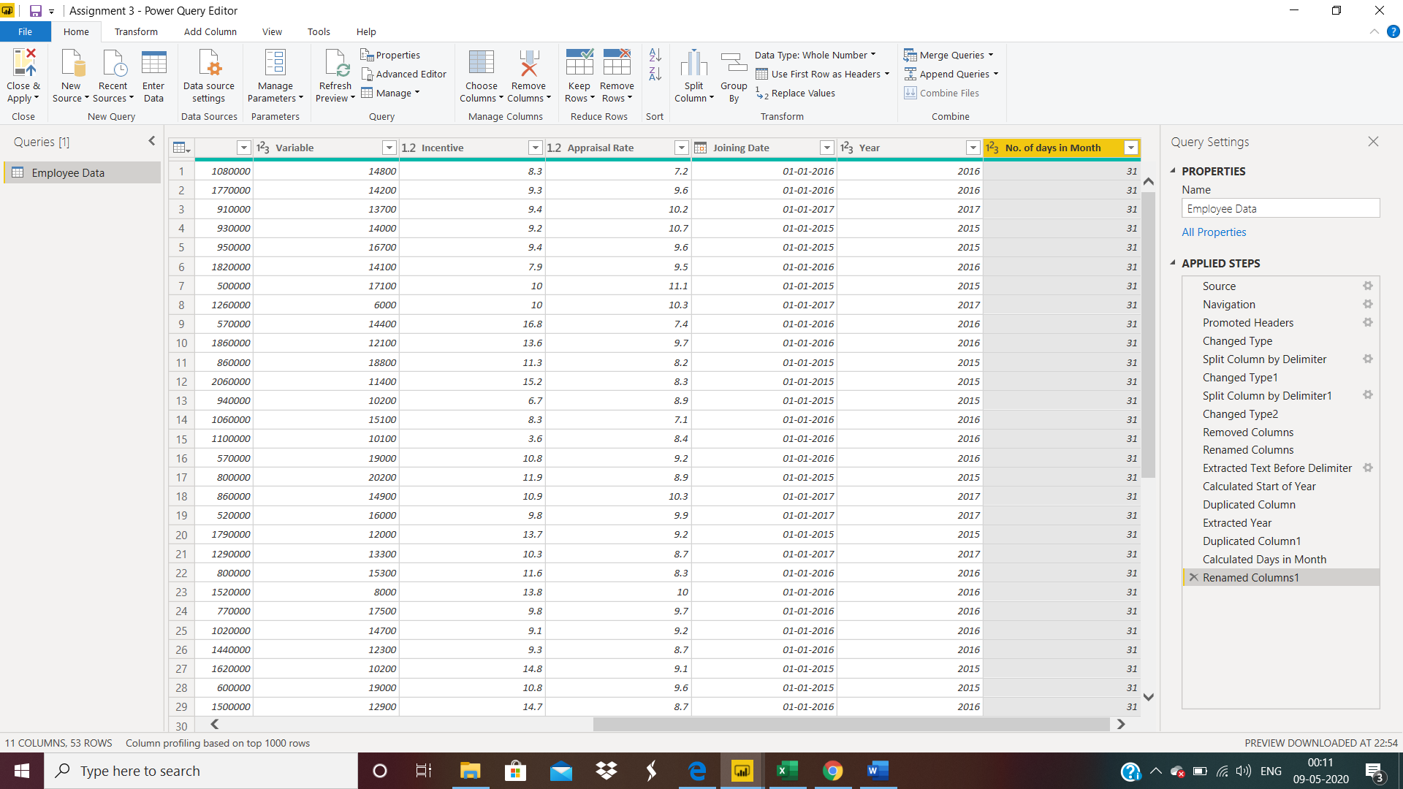

Advanced Editor

The **Advanced Editor** lets us see the code that Power Query Editor is creating with each step. It also lets to create your own shaping code.

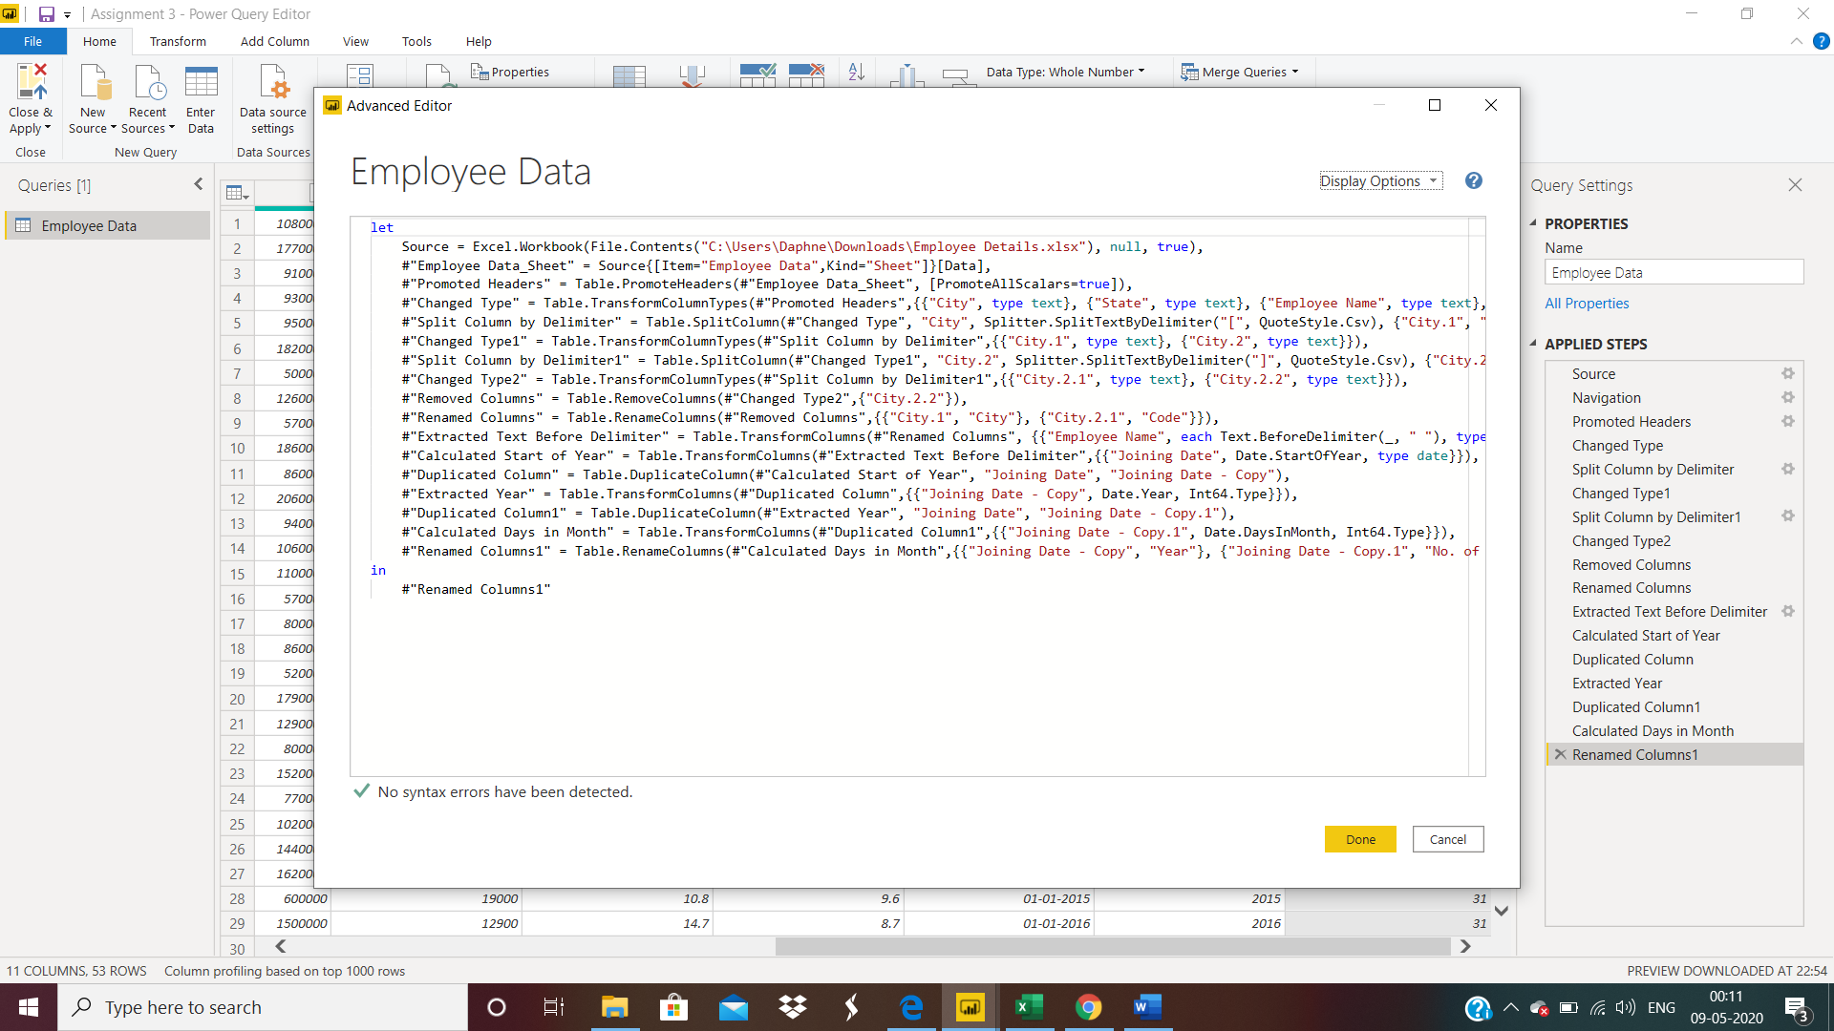

POWER BI DESKTOP

**Power BI Desktop** is a free application you install on your local computer that lets you connect to, transform, and visualize your data. ... Most users who work on business intelligence projects use Power BI Desktop to create reports, and then use the Power BI service to share their reports with others. **PRICE** - It’s a FREE application.

POWER BI PRO

**Power BI Pro** is an individual user license that lets users read and interact with reports and dashboards that others have published to the Power BI service. Users with this license type can share content and collaborate with other Power BI Pro users. **PRICE** : $9.99 Monthly price per user.

POWER BI PREMIUM

**Power BI Premium** is a tenant-level Office 365 subscription available in two SKU (Stock-Keeping Unit) families: P SKUs (P1-P5) for embedding and enterprise features, requiring a monthly or yearly commitment, billed monthly, and includes a license to install Power BI Report Server on-premises.

**PRICE** : $4995 Monthly price per dedicated cloud compute and storage resource with annual subscription.

Monthly price per dedicated cloud compute and storage resource with annual subscription

Monthly price per dedicated cloud compute and storage resource with annual subscription

Monthly price per dedicated cloud compute and storage resource with annual subscription